Social Media
Grassroots Promotion in Local Community
Curated a post on several local ‘town’ Facebook pages, to encourage participation in The Precious Child Fundraiser taking place nearby. 45 volunteer positions needed to be filled in 7 days. By including a sign-up link, readers could quickly volunteer for the 2nd annual trail marathon. The non-profit earns a large monetary donation by overseeing all course volunteer work. By doing so, one volunteer was recruited immediately.  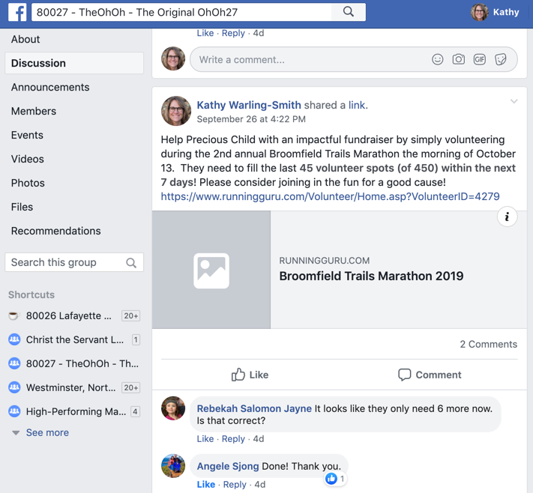 | Created awareness that high school mountain biking is a club sport offered at the two high schools. With Centaurus in its inaugural year,  by promoting the Sophomore Boys success it effectively sparked curiosity as a reader requested additional information. With awareness, future membership should grow.  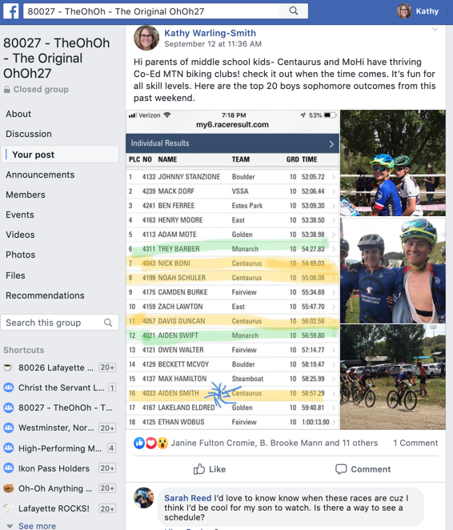
With the high-volume group subscriber base, the following post reminded locals of an annual food drive occurring at a local grocery store on Sunday, supporting the local food bank. By making the event top of mind, it allowed citizens to schedule their weekend shopping around the event to help contribute. 771 pounds of food was collected.  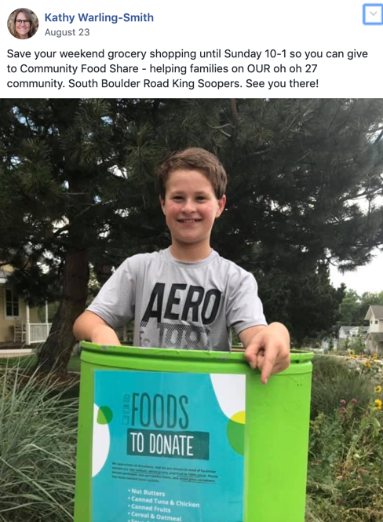 | A Lutheran-based summer sleep over camp in Colorado was hosting a 5K run to raise money for world food relief. Since many of our congregation members having kids who attend the camp as either campers or counselors, I felt others would appreciate having the event called to their attention. I pulled the content from the email and placed it on our church Facebook page.  