Actual Website Pages
Gallery Page

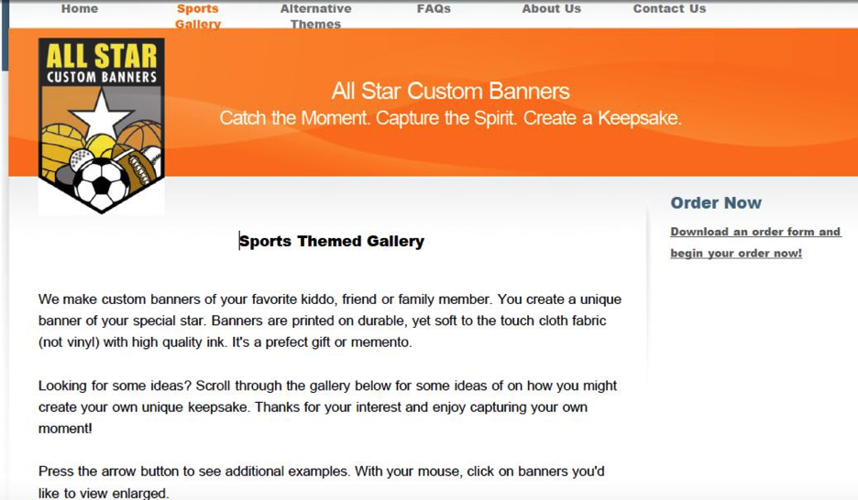

About Us Page

