**Recent InDesign Projects**

Employee Engagement Poster crafted as an active committee member.

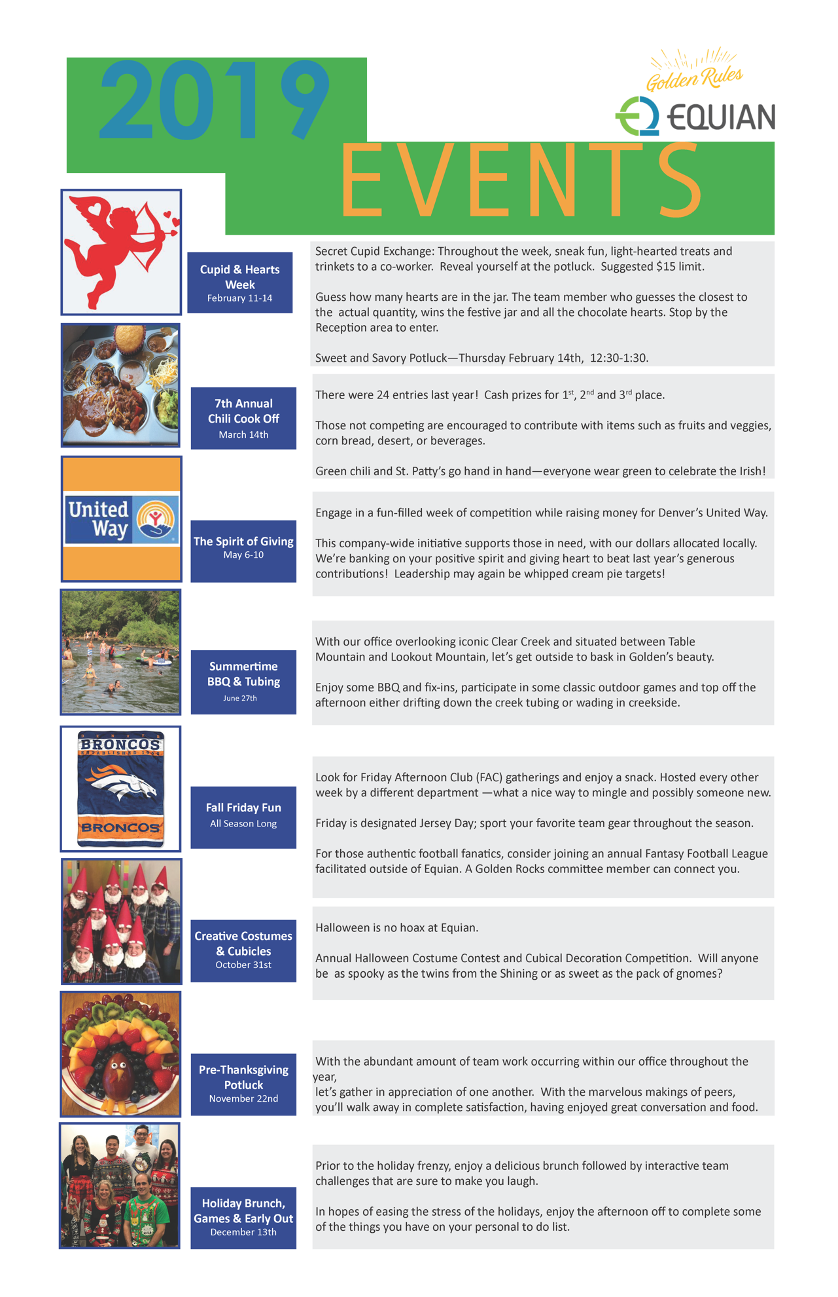

**Mother’s 80th Birthday Party Invitation**

