Payment Integrity Reporting

Migration to Tableau
When joining Equian my first hefty undertaking was migrating the enterprise client’s report package from Pentaho to Tableau. There were 15 reports whereby I provided specifications to the programmers along with visual references. In four-months’ time I was able to QA the reports, have revisions made and have final, approved templates released.

Client-Facing Reporting Dashboard
A year later, to provide the client increased reporting accessibility and to ideally reduce the amount of time I allocated to reporting needs, a Report Dashboard Development Committee including myself collaborated on the a client-facing tool. The dashboard was successfully released and adopted by the client.

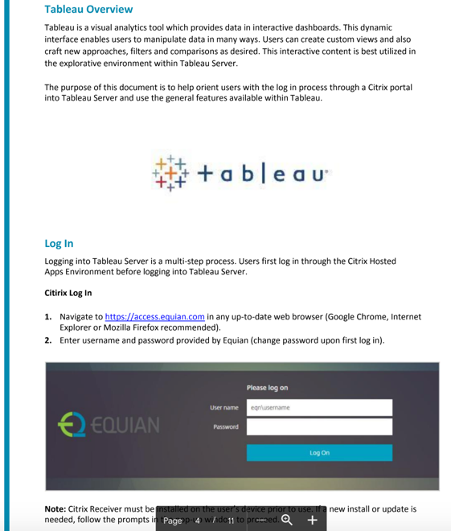

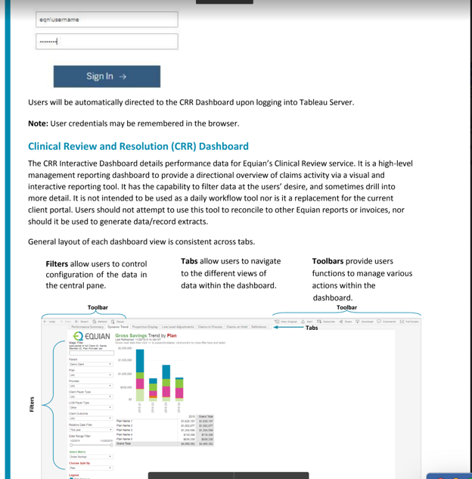

Quarterly Business Reviews
For quarterly on-site business reviews, I would prepare the Clinical Review and Resolution line of business statics and highlight the successes and opportunities incorporating content into the master slide deck.

Savings Highlighted by Line of Business:
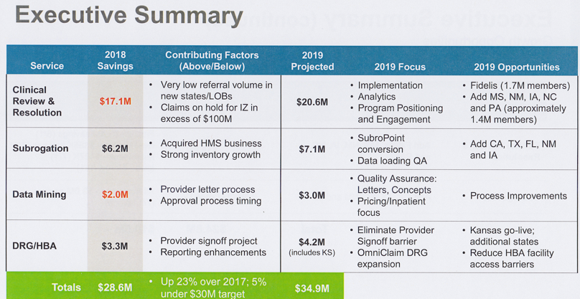

Year over Year Growth Summary:
