FEP Mad Pow Flash Feedback
FEP Feedback from last Draft that is still incorrect on the Flash Production:
- Introduction Title should be “MyBlue Benefit Statement”
- Orange button in upper right corner: change verbiage to “View Your Benefit Statement”
- “Individual Medical & Pharmacy Claims” verbiage is cut off by the Benefit Statement screenshot (this can be shortened to “Individual Medical & Rx Claims” if that fits better)
- Mid-way through the “overview” section: the verbiage should state “Quarterly MyBlue Benefit Statement”
- Decisions page: change verbiage to “…Benefit Statement”
There were a couple of issues with the Benefit Statement screenshots:
The Benefits at a Glance screenshot looked good.
For Current Year total Costs:
- In Green: We need the individual “Deductible Amount” equal to $300.00 and we need the Family “Deductible Amount” to equal $600.00 (we can maybe just have this photo shopped in OR you can use the user I outline below to go to UAT and grab an updated screenshot).
- In red – can we include at least one provider name in this list? (we can maybe just have this photo shopped in OR you can use the user I outline below to go to UAT and grab an updated screenshot).
Currently in Mad Pow video:
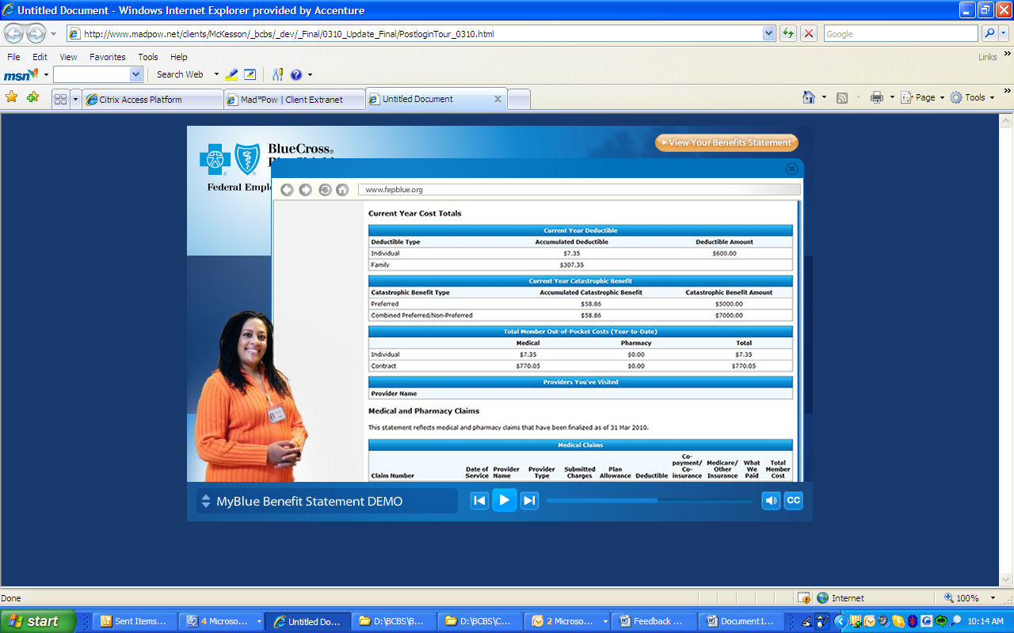
This is the suggested screenshot from UAT (use the user UAT_MS_G1_01):
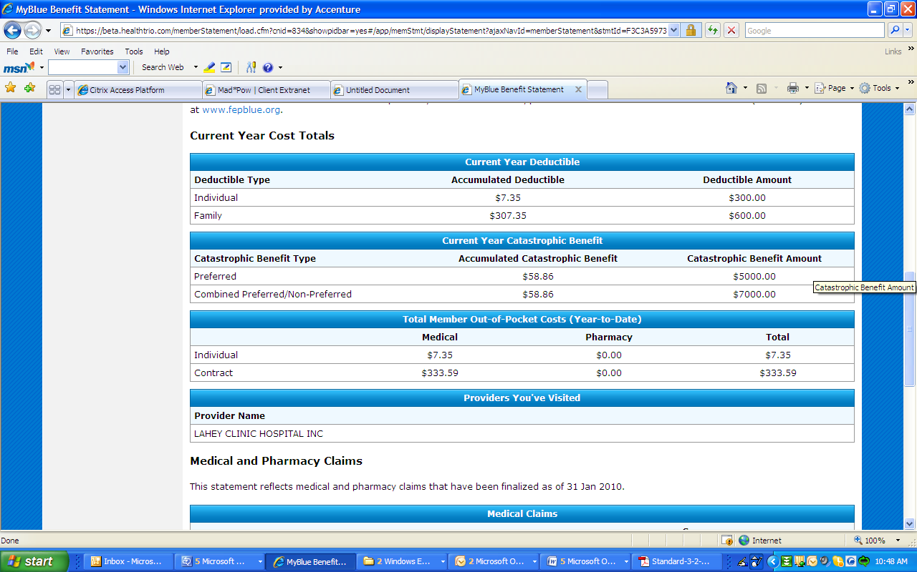

Medical and Pharmacy Claims section:
Is there any way that we can get some Pharmacy Claims listed? The user UAT_MS_G1_01 does NOT have RX claims in production. We could potentially Photoshop in the screenshot I have below.
If you go to the UAT environment for user UAT_MS_G1_01, can we have an updated screenshot with the Provider Name field filled in?
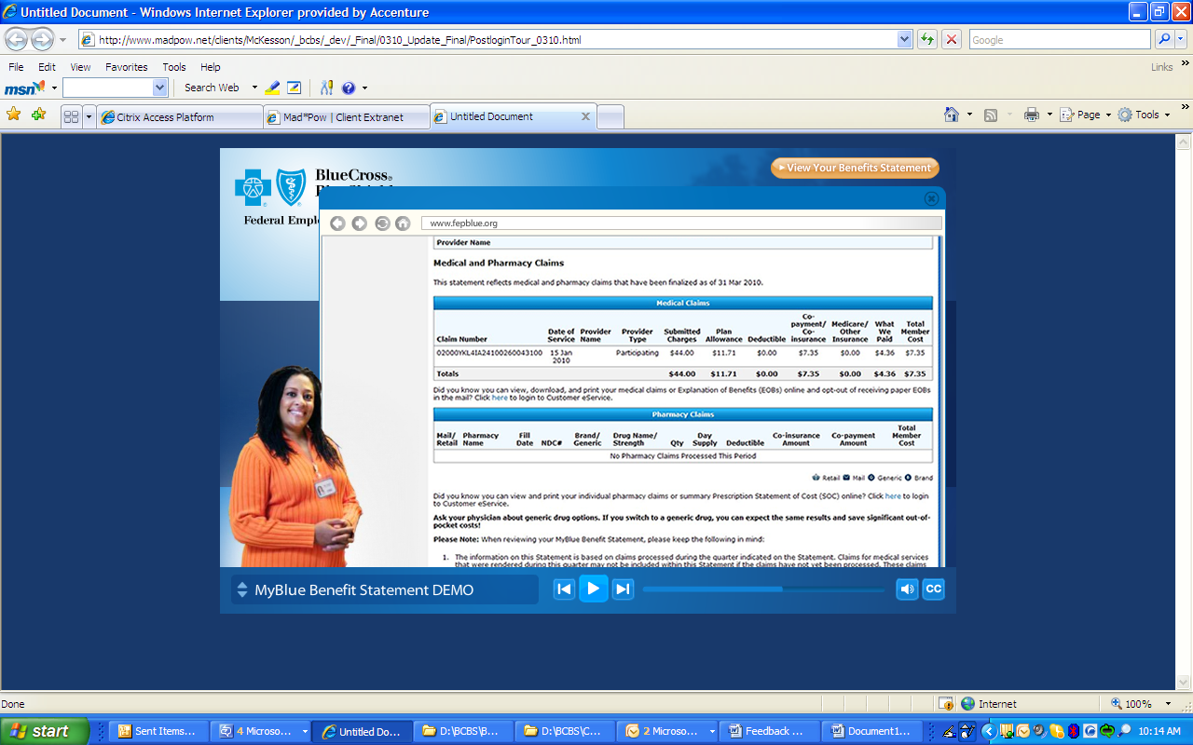
Suggested Screenshot (for the Medications Claims section). Since this does not have Rx Claims listed, I was wondering if we could Photoshop in the RX claims list from the final mock up? I also copied this below.
Screenshot:
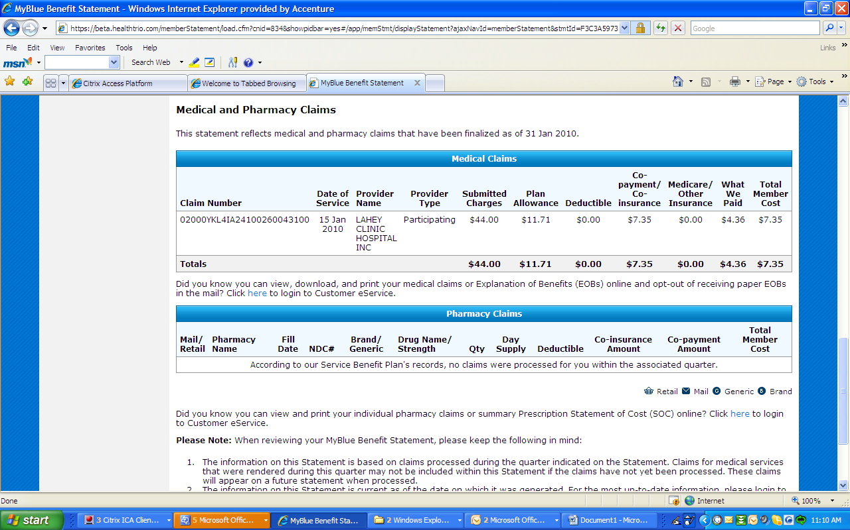
Suggested Photoshop - Can we potentially just Photoshop the following in for the Pharmacy Claims?
