**Pre and Post Website Carousel Banners**

Promote various tools available and links them to each.

|  |  |
| --- | --- |
|  |  |

**Guest User Landing Page**

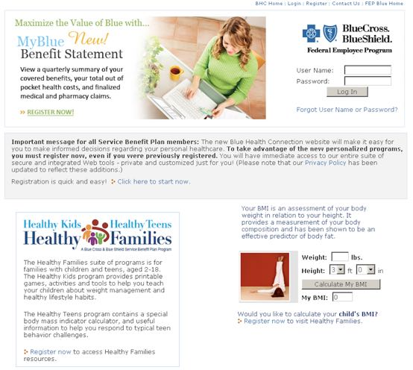

|  |  |
| --- | --- |
| **Registered User Landing Page**  Led the team of creative team members who crafted the copy and design of new consumer portal. I was responsible for reviewing with product manager and client, gaining final approvals. | **Incentive language associated with Assessment completion.**  **Variable Smart Messages**  Purpose is call attention to Health Assessment tool and incentive, encouraging member to  participate in Q1 of the year.        Screen illustration not reflected. |

Conducted user acceptance testing (UAT) and guided client on process. Worked directly with development team on required adjustments.

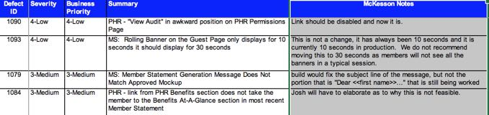

**FAQ section of consumer portal**

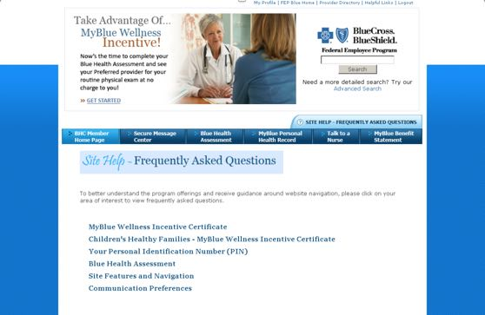

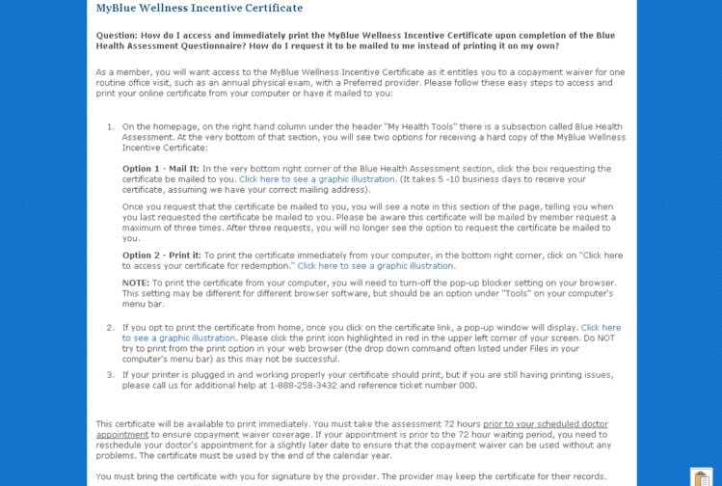

**Adult Incentive: Blue Health Assessment**

**Program Overview:**

When a member completes a Blue Health Assessment they will receive MyBlue Wellness Incentive certificate. This certificate entitles the member to a copayment waiver for one routine office visit, such as an annual physical exam.

**Sample Certificate**

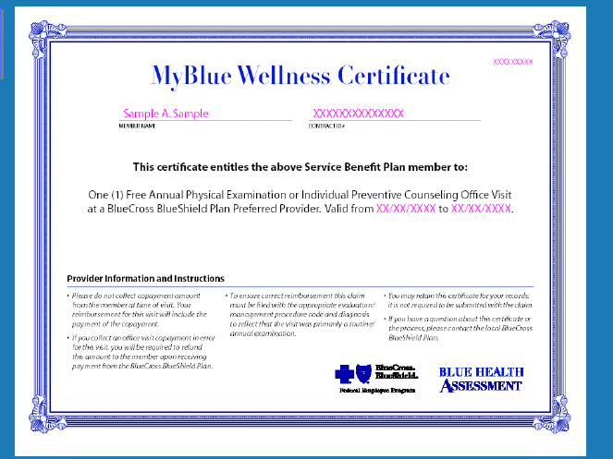

**How do I access the Blue Health Assessment?**

Log on to [www.fepblue.org](http://www.fepblue.org), scroll down the home page and select Blue Health Assessment link. Alternatively there is a Health + Wellness link that lists all the wellness program where the member could click on the Blue Health Assessment link located on the left navigation bar. Members will be directed to the overarching Blue Health Connection program website. Here they either need to register as first time users or log on if previously registered in 2010. (Note: all members, regardless if they registered prior to 1/1/2016, must re-register after 1/1/2016.)

Once registered, the member needs to select the Blue Health Assessment link as noted in the screen shot below This link will take you to the Blue Health Assessment tool.

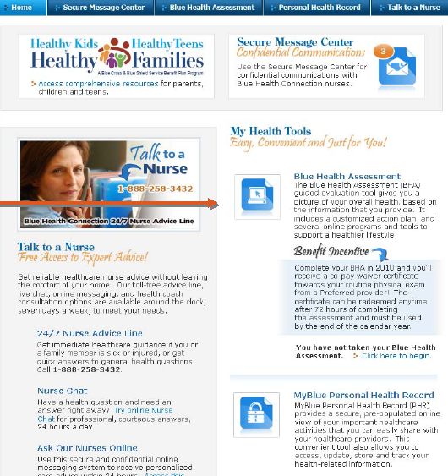

**Once on the Blue Health Assessment online tool the member will access the assessment by pressing “Start Questionnaire.”**

**Worked with partner vendor to have the screen wrap reflect client branding.**

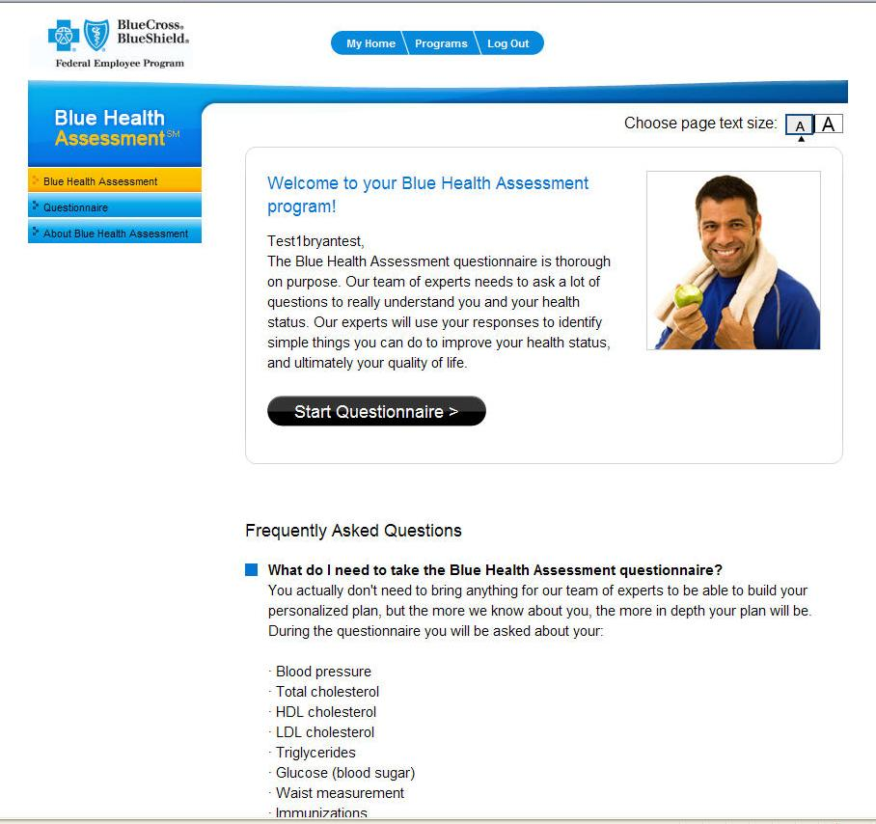

**How Member Accesses the Certificate:**

The online program will direct members to either print the certificate off their computer right then and there OR they can request the certificate be sent to them. Below is the type of instructions the member will receive.

**Certificate Print Out Window - for adults completing BHA**

**How Member Accesses the Certificate:**

The online program will direct members to either print the certificate off their computer right then and there OR they can request the certificate be sent to them. Below is the type of instructions the member will receive.

**Certificate Print Out Window - for adults completing BHA**

Congratulations on completing the Blue Health Assessment!  Here’s your MyBlue Wellness Certificate that can be used to waive your copayment for your annual physical when you visit a Preferred provider.  Be sure to schedule an exam and, if you like, bring along your Blue Health Assessment action plan so you and your provider can discuss active steps to a healthier you.  Step-by-step instructions for redeeming the MyBlue Wellness Certificate are listed below.

**Instructions for redeeming your MyBlue Wellness Incentive Certificate:**

1.  This certificate will be available to print immediately. You certificate will be redeemable in

72 hours and is valid through December 31st, 2010.

2.  This certificate is valid for one (1) physical exam or preventive visit from a Preferred

provider in the 2016 calendar year. Your provider’s office will track certificate

redemption

3. You must bring the certificate with you for signature by the provider.  The provider

may keep the certificate for their records.

4.   If you misplace the certificate after you print it, you can revisit the website and reprint

the certificate or request that the certificate be mailed to you. ** The certificate is posted on your Blue Health Connection homepage, under the Blue Health Assessment section.

**Please note this certificate will be mailed by member request a maximum of three times, after that you will no longer see the certificate posted on the Blue Health Connection homepage.

**Health Families Page**

Original art not available, scanned instead.

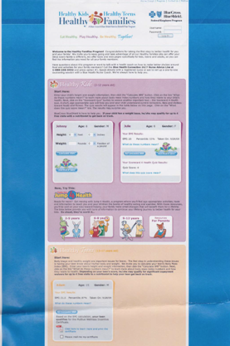

**New Benefit Statement Tool**

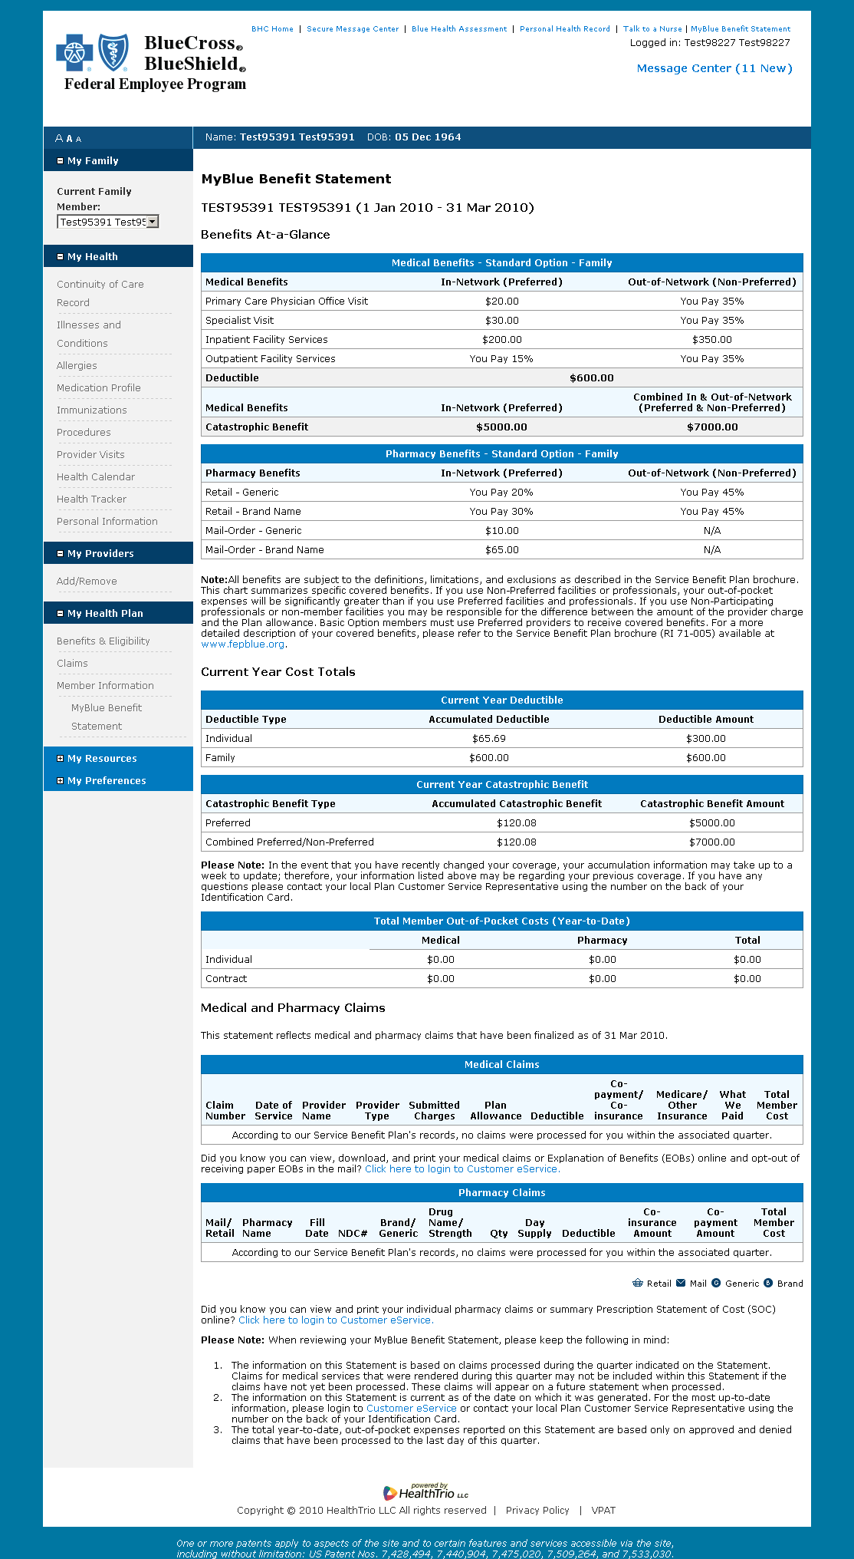

Scroll down please.

**Sample Email to Member**



[Message subject line: Notification from Blue Health Connection]

Dear «FIRST_NAME» «MI» «LAST_NAME»:

This e-mail has been sent from the Blue Health Connection website to notify you of a new message containing important health-related information waiting in your Secure Message Center.

Click here to access your Blue Health Connection home page and Secure Message Center. Login with your User Name and Password then click the “Login” button. You will see the Secure Message Center in the upper-right corner of the page.

If you have any questions about your Blue Health Connection account, or if you would like to speak with a Blue Health Connection nurse, please contact us at 1-888-BLUE-432 (1-888-258-3432). Our nurses are available 24 hours a day, seven days a week to serve your healthcare needs.

Thank you!

To unsubscribe from e-mail notification of new messages, logon to the Blue Health Connection website. Go to “My Profile” then select “My Preferences.” Finally, click on the “Notification of New Messages” checkbox to uncheck the box. You will be unsubscribed from future e-mail messages of this nature within 10 days.

Please do not respond to this e-mail. For technical support questions, call 1-888-BLUE-432 (1-888-258-3432).