**BCBS of Minnesota Branding**

Below are two of the different “looks” over the years, meetings different creative director style guide directives.

As an extension of their marketing department, our organization had access to the BCBSMN branding portal where imagery can be downloaded, etc.

|  |  |
| --- | --- |
|  |  |
|  |  |

Inside panel of a self-mailer illustrates how we added a summer safety message to the nurse line message, meeting clients multiple goals.

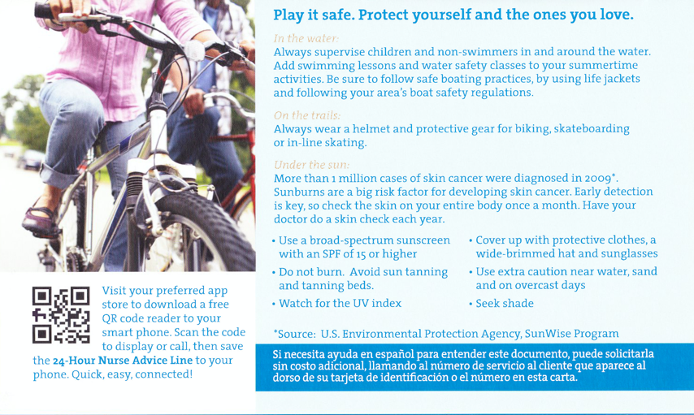

Different campaign look and feel in prior years met BCBSMN branding standars.

|  |  |
| --- | --- |
|  |  |

**Version Management**

Blue Cross Blue Shield of Minnesota required six different versions driven by line of business. Versioning adjustments involved primary logo, legalese such as Medicaid and Medicare language requirements, approval codes, imagery, color and terminology variation such as health care vs. healthcare.

|  |  |
| --- | --- |
|  |  |
|  |  |
|  |  |